**Collaborating using Repository Github “it-perbankan-finpro-kelompok4”**



**Nama : Muhamad Komar Hidayat**

**Nim : 2011500747**

**Profil Link :** [**https://www.rakamin.com/profile/muhamad-komar-hidayat-b27ttkjac5z47qil**](https://www.rakamin.com/profile/muhamad-komar-hidayat-b27ttkjac5z47qil)

**Link Github Repository**

[**https://github.com/komarkun/-it-perbankan-finpro-kelompok4.git**](https://github.com/komarkun/-it-perbankan-finpro-kelompok4.git)

**Beranda Repository**

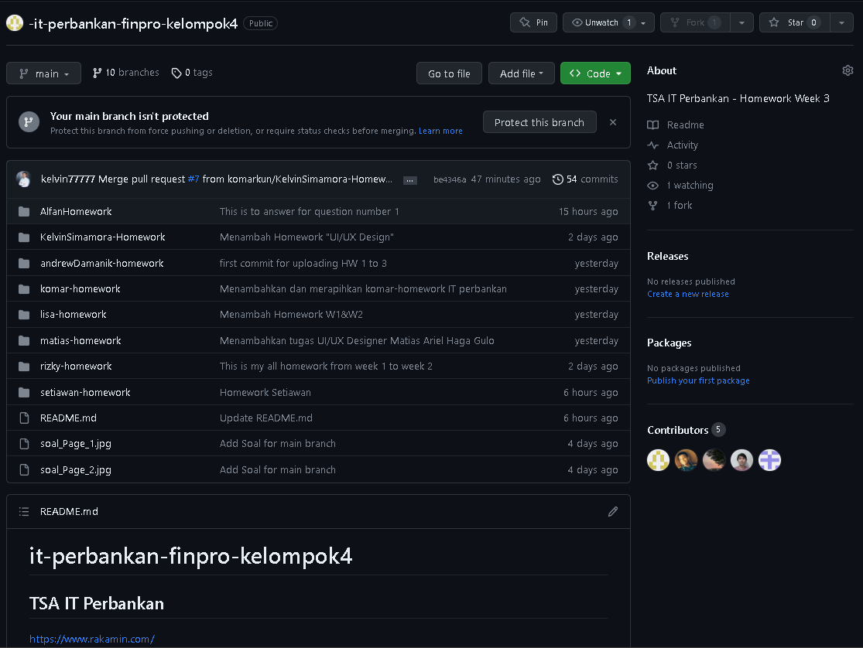

**Anggota Kelompok 4**

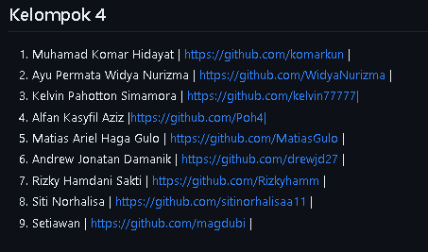

**Kontributor**

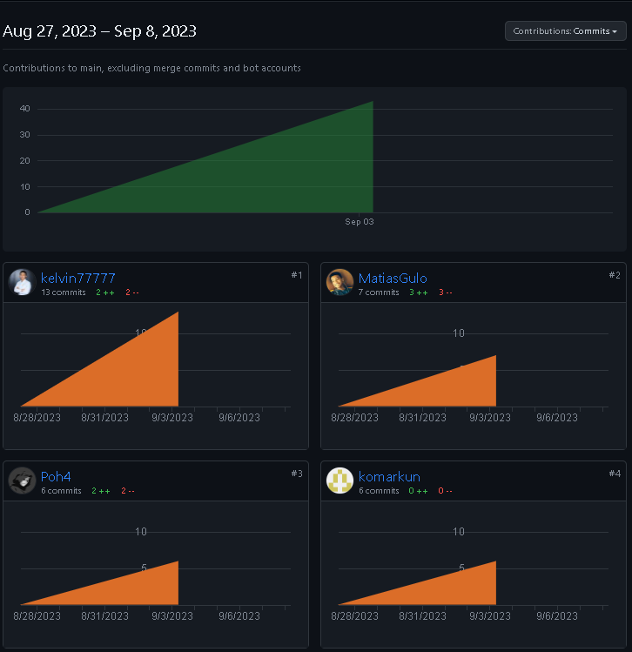

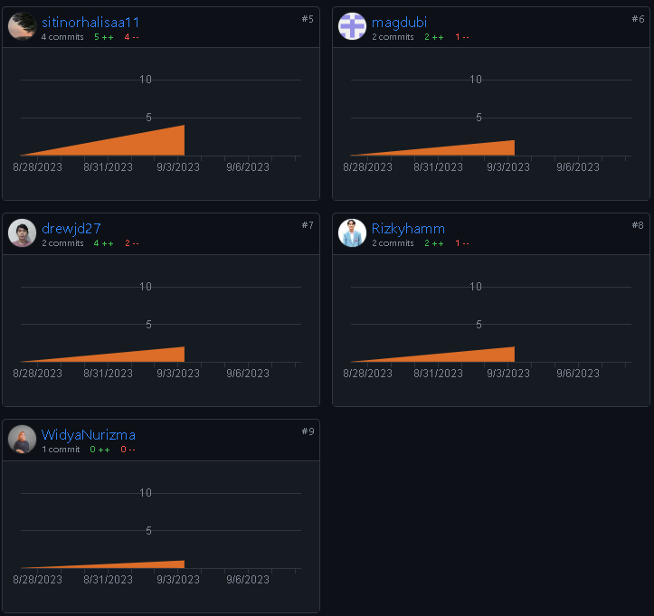

**Network Branch**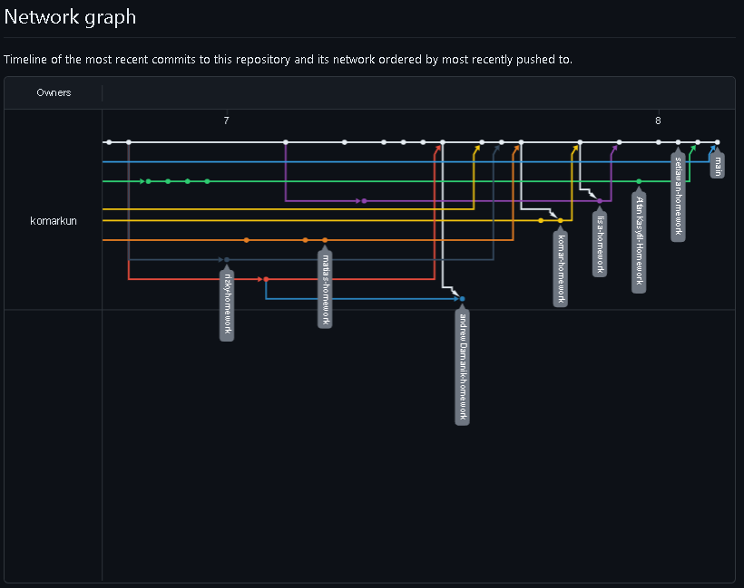

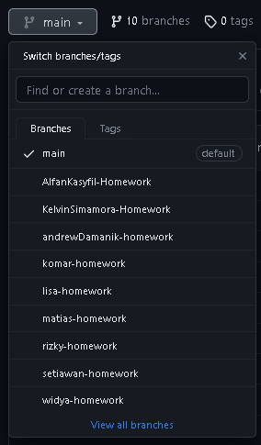

**Local save the file**

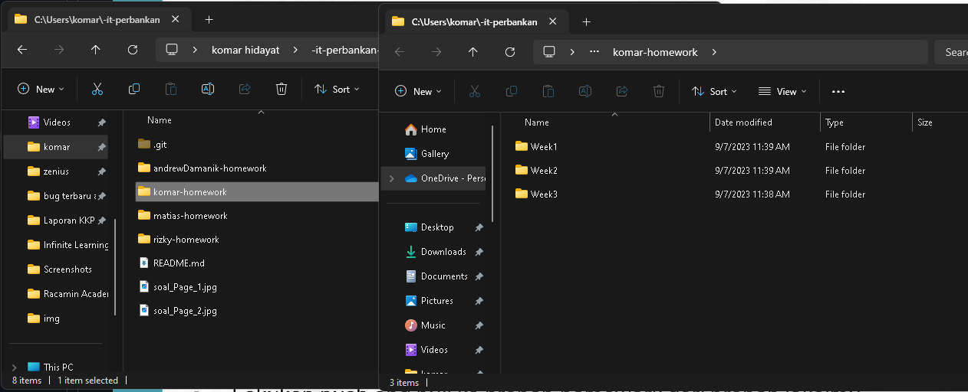

**Pull and Merge History**

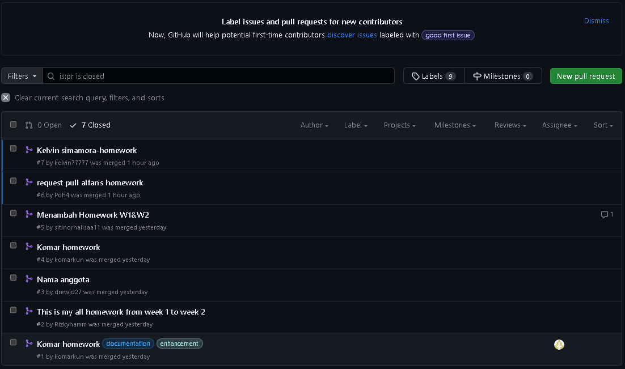

**Commit History komar-homework**

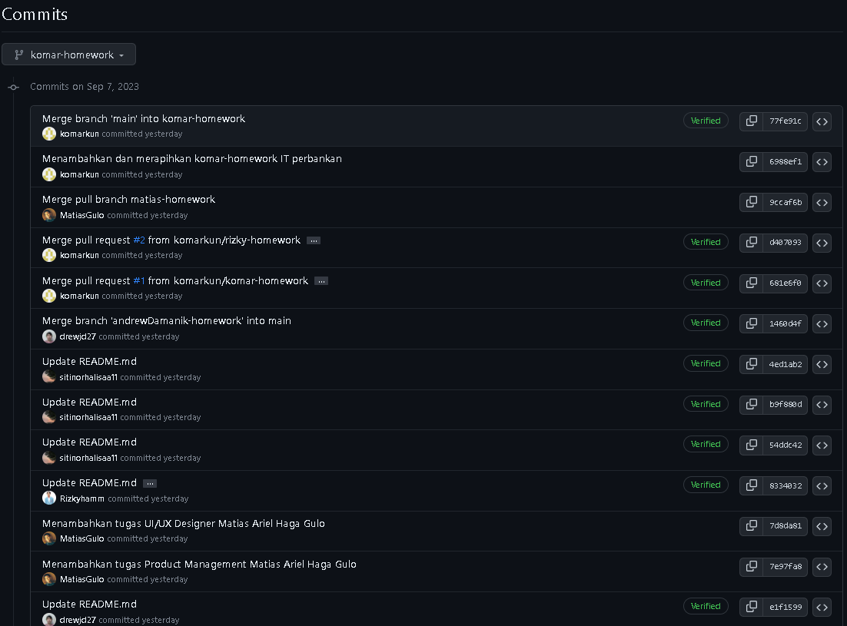

**Commit History main branch**

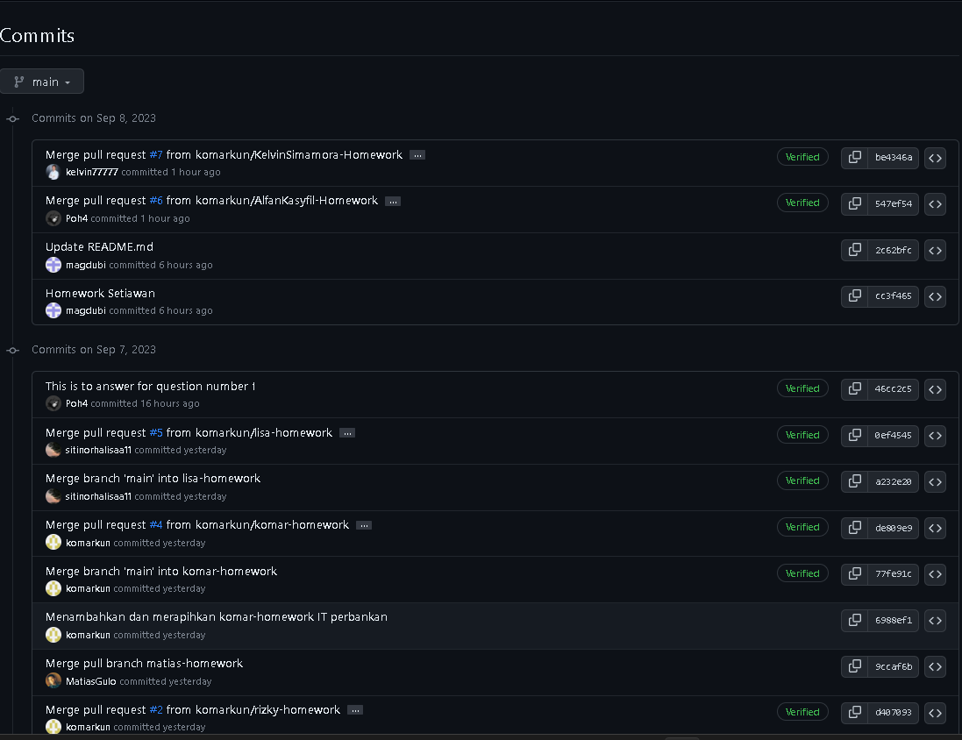

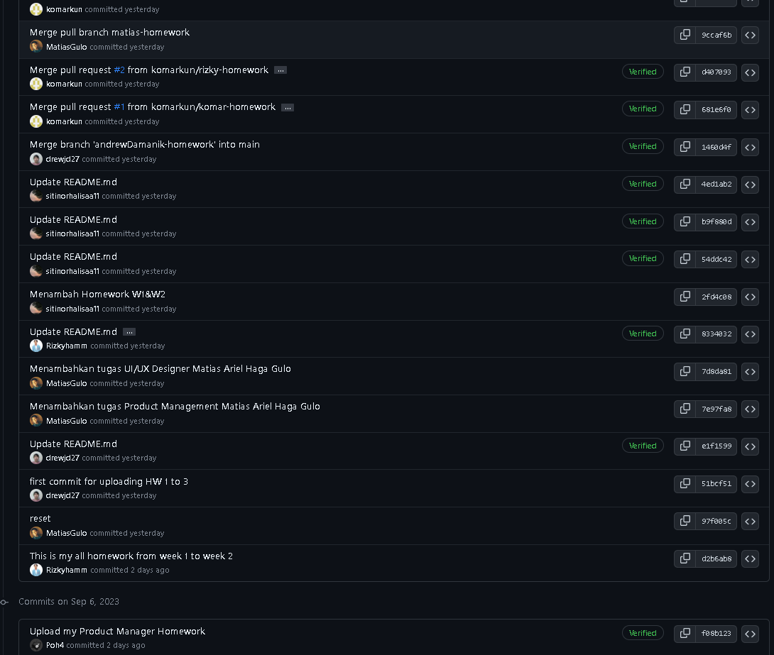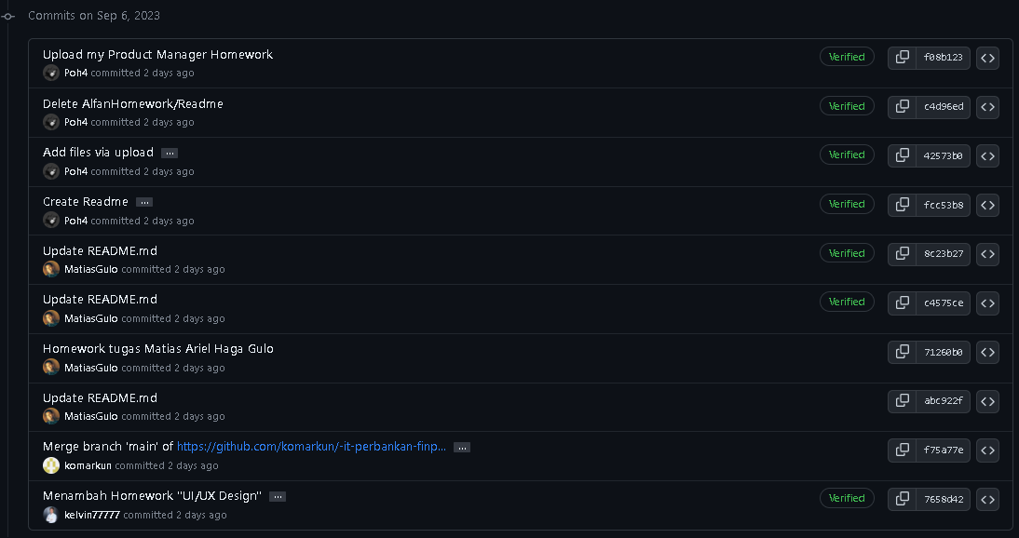

**Pull and Merge History**



**Result Pull Request and Merge in main Repository**

